Avionic Updates

1. Garmin G500 TXI instead of G500

The G500 TXi is a display and sensor system available in three display options:

* GDU 1060 – 10”display
* GDU 700P – 7”portrait display
* GDU 700L – 7”landscape display

Display options can be seen at Figure 1. Depending on system specifics one or more of the following functions may apply:

1. **Primary Flight Display (PFD)** – provides attitude, heading, air data, and navigation information to the pilot
2. **Multi-Function Display (MFD)** – provides pilot awareness of factors that may affect the overall conduct of a flight
3. **Engine Indicating System (EIS)** – provides engine and airframe operating parameters to the pilot

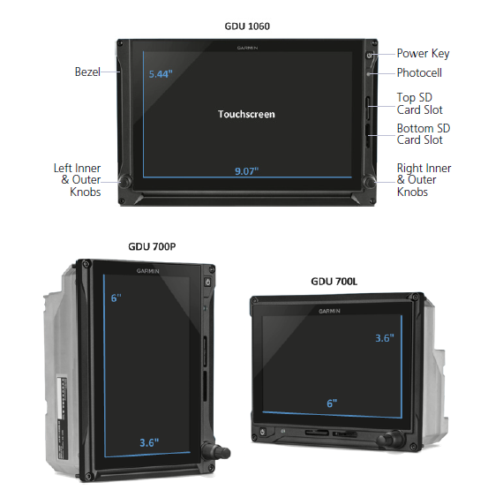

Figure 1 Display Options for G500 TXI

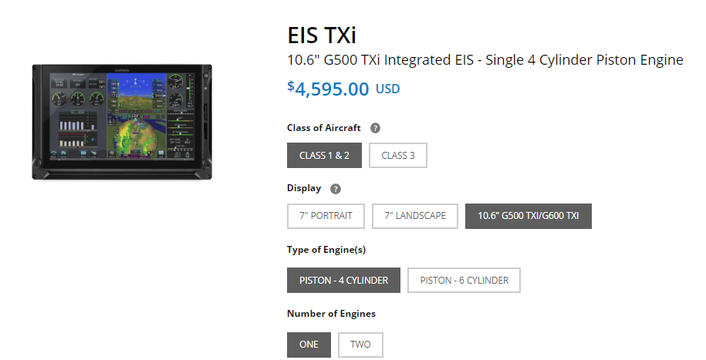

Figure 2 Garmin EIS TXI

Due to its natural support to EIS, we decided to use G500 TXI over G500. With an integrated EIS at Figure 2, G500 TXI can simply display any vital engine information at its screen. Considering the display configurations for the 1060, 700P and 700L at Figures 3,4 and 5 respectively, we decided to use 10” configuration of the G500 TXI instead of dual 7” option. Using MFD/PFD/EIS configuration, pilots can be informed about the plane mostly from one device.

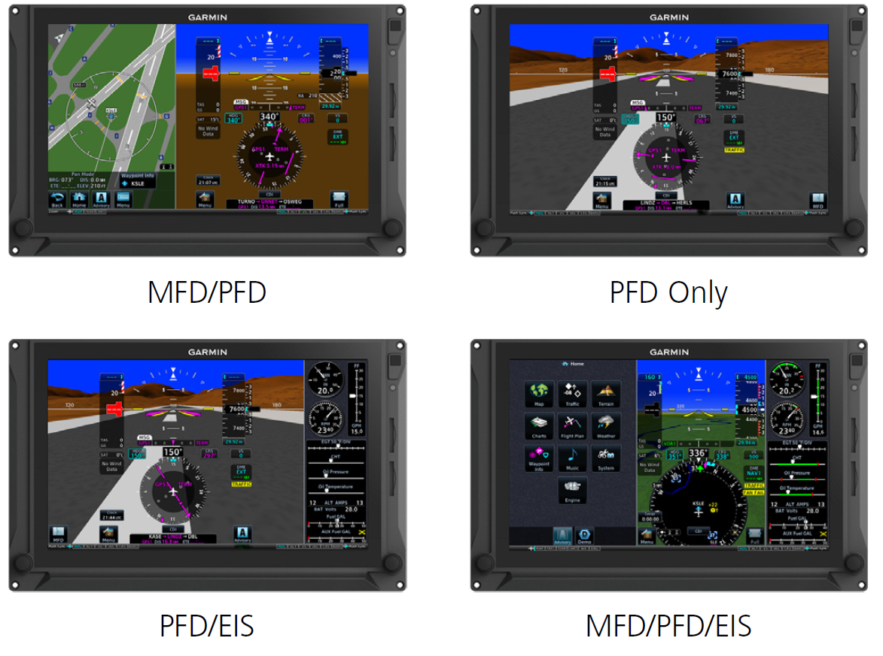

Figure 3 GDU 1060 Display Configuration

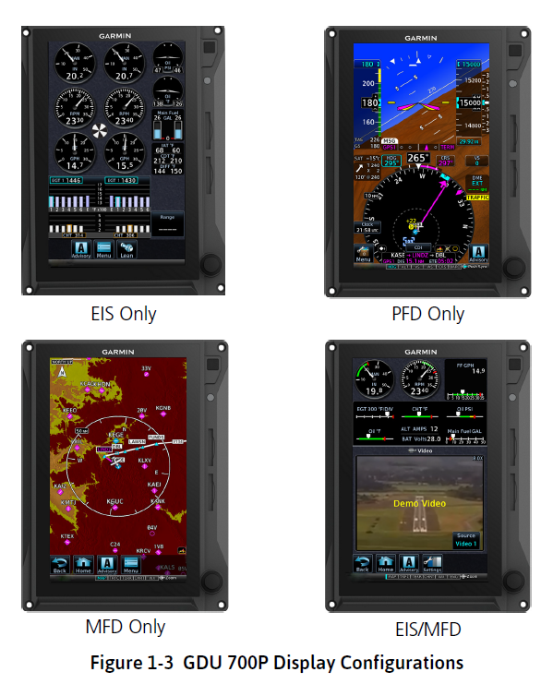

Figure 4 GDU 700P Display Configuration

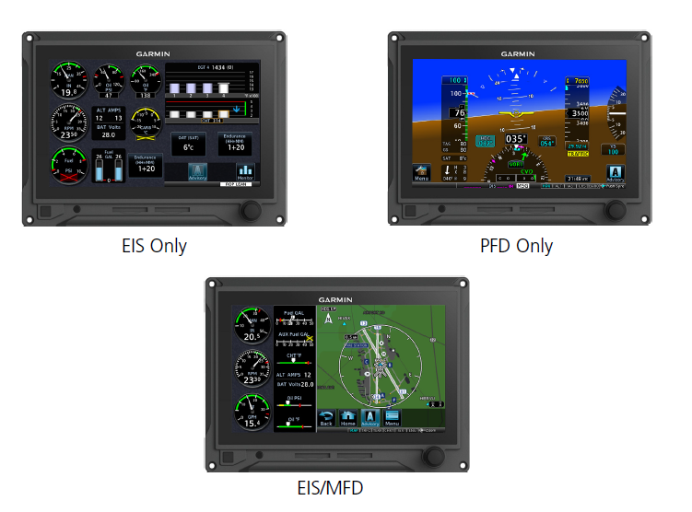

Figure 5 GDU 700L Display Configuration

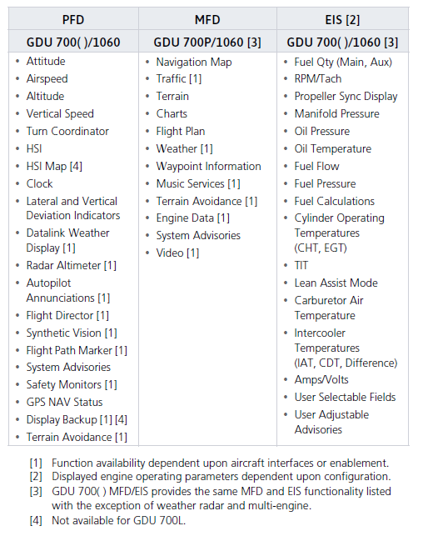

Figure 6 System Functions

System functions of G500 TXI can be seen at Figure 6 while electrical loads of subsystems of G500 TXI can be seen at Figure 7.

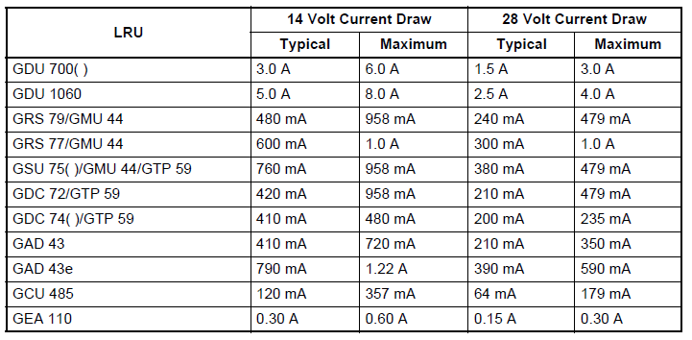

Figure 7 Electrical Load of Subsystems of G500 TXI

* 1. Subsystems of Garmin G500 TXI

**GDU 1060 Display**

The GDU 1060 is a 10.6-inch LCD panel mount control and display unit capable of displaying PFD and MFD data with optional EIS display. The GDU 1060 may be optionally equipped with an integrated

ADAHRS or must be interfaced to an external ADC/AHRS LRU. The GDU 1060 requires interface with a compatible GPS/SBAS navigator.

**GCU 485 Control Unit**

The GCU 485 is a panel mount remote control unit that provides an alternate method of controlling the G500/G600 TXi PFD display parameters. The GCU 485 Control Unit is available in variations containing different numbers of buttons. All variations contain three knobs in the same configuration as shown in Figure 8 The GCU 485 installation is optional.

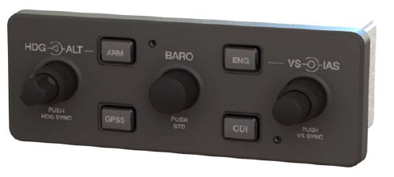

Figure 8 GCU Control Unit

**Backup GPS Antenna**

GDU 1060 and GDU 700 PFD and MFD displays have an optional backup GPS. If a backup GPS antenna is installed, the backup GPS is automatically used when the primary GPS source is lost. The backup GPS antenna is located on the instrument panel glareshield.

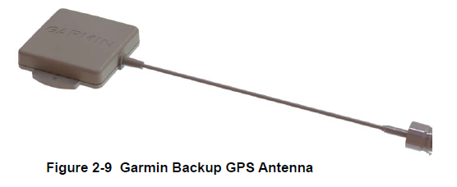

Figure 9 Backup GPS Antenna

**Integrated ADAHRS Unit**

The GDU 700/1060 has an optional integrated ADAHRS unit that provides flight altitude, vertical speed, airspeed, attitude, OAT, and heading data for flight instrumentation. The AHRS portion is contained internally within the GDU 700/1060. An Integrated ADC module is then plugged into the AHRS board and attached to the back of the GDU 700/1060. The internal ADAHRS receives data from the GMU 44 and GTP 56 that are connected to the GDU 700/1060. The integrated ADAHRS utilizes GPS signals sent from the GPS/SBAS navigator. Attitude, heading, and air data can be sent using ARINC 429 digital signals to external LRUs and the GAD43/43e.

**GSU 75( ) ADAHRS Unit**

The GSU 75/75B ADAHRS is a remote LRU that provides flight altitude, vertical speed, airspeed, attitude, OAT, and heading data for flight instrumentation. The GSU 75/75B receives data from the GMU 44 Magnetometer and GTP 59 OAT Probe. The GSU 75/75B utilizes GPS signals sent from the GPS/SBAS navigator. Attitude, heading, and air data is sent using ARINC 429 digital signals to the GDU 1060/700P and GAD 43/43e. An RS-232 digital connection is used for maintenance and configuration information. The GSU 75B is configured through the GDU 700P/1060 using a feature unlock card that contains airframe specific air data corrections suitable for RVSM functionality in select applications. The device can be seen at Figure 10.

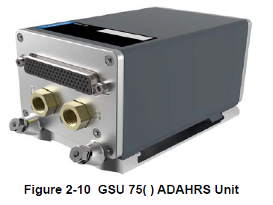

Figure 10 GSU() ADAHRS Unit

**GRS 79 AHRS Unit**

The GSU 79 AHRS is a remote LRU that provides attitude and heading data for flight instrumentation. The GSU 79 receives data from the GMU 44 Magnetometer. The GSU 79 utilizes GPS signals sent from the GPS/SBAS navigator. Attitude and heading data is sent using ARINC 429 digital signals to the GDU 700P/1060 and GAD 43/43e. An RS-232 digital connection is used for maintenance and configuration information. Device can be seen at Figure 11.

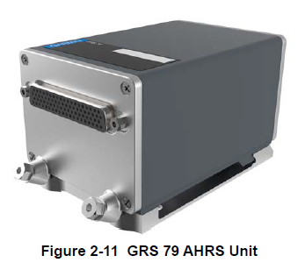

Figure 11 GRS 79 AHRS Unit

**GDC 72 ADC Unit**

The GDC 72 Air Data Computer receives information from the existing aircraft pitot-static system and the GTP 59 OAT Probe. The GDC 72 provides pressure altitude, airspeed, vertical speed, and OAT data to the G500/G600 TXi system. The GDC 72 provides data to the G500/G600 TXi using ARINC 429 digital interfaces, as well as RS-232 for maintenance and configuration information. Device can be seen at Figure 12.

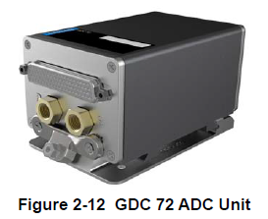

Figure 12 GDC 72 ADC Unit

**GMU 44 Magnetometer**

The GMU 44 Magnetometer senses magnetic field information and sends the data to the GSU 75/75B, integrated ADAHRS, or GRS 77/79 AHRS to determine aircraft magnetic heading. This unit receives power directly from the AHRS source and communicates with the AHRS using an RS-485 digital interface. Device can be seen at Figure 13.

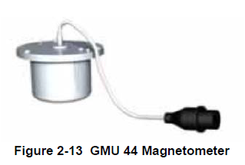

Figure 13 GMU 44 Magnetometer

**GTP 59 OAT Probe**

The GTP 59 is a remote mount temperature probe that interfaces to the ADC for OAT display and true airspeed computations. The GTP 59 is mounted externally on the aircraft, usually near or inside air inlet ducts, the underside of wing access panels, or on the empennage below the horizontal stabilizer. Device can be seen at Figure 14.

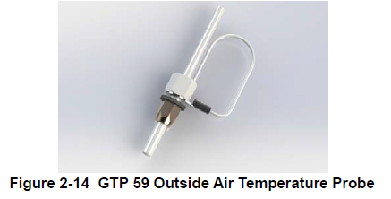

Figure 14 GTP 59 Outside Air Temperature Probe

**GBB 54 Backup Battery**

The GBB 54 supplies power to the GDU 700P, internal ADAHRS, essential EIS sensors, and a single

GEA 110 in the event of total electrical power loss. Device can be seen at Figure 15.

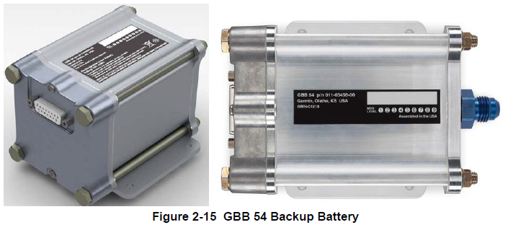

Figure 15 GBB 54 Backup Battery

**GEA 110 Engine Interface**

The GEA 110 is a remote mount engine interfacing and monitoring module used for gathering sensor input parameters from the engine and processing the signals for the G500/G600 TXi system. The GEA 110 can be mounted to the back assembly of the GDU 1060 or it can be remotely mounted in the fuselage or in the engine compartment. The GEA 110 communicates with the G500/G600 TXi using an RS-485 digital interface. Device can be seen at Figure 16.

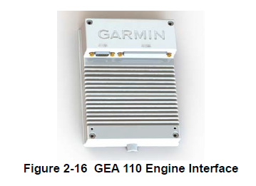

Figure 16 GEA 110 Engine Interface

**GAD 43/43e Adapter**

The GAD 43 Adapter is an optional adapter that provides attitude, heading, and yaw input information for third-party autopilot systems. It also provides a synchro heading output that can be used to provide synchro heading to other systems. The GAD 43/43e can provide the following information in analog format:

* Pitch and roll for the autopilot (synchro)
* Pitch and roll for weather radar stabilization (50 and 200 mV/degree)
* Heading (synchro)
* Yaw rate (100, 200, 333, and 600 mV/degree/sec)

**OR**

* The GAD 43/43e can provide an analog baro-correction output like the Honeywell KEA 130/130A

and KEA 346 (P/Ns 006-0362-0008 through -0011 only) encoding altimeters With the GDU 700/1060 in Configuration mode, the GAD 43/43e also allows the installer to set the analog attitude and heading outputs to specific values without the need for removing any gyros and using a tilt table.

The GAD 43e provides all of the functions of the GAD 43. In addition, it allows the G500/G600 TXi to receive data from marker beacon receivers, synchro (ARINC 407) ADF receivers, DME systems, and

analog radar altimeters. It also allows the G500/G600 TXi to provide altitude preselect and vertical speed

control to compatible autopilots.

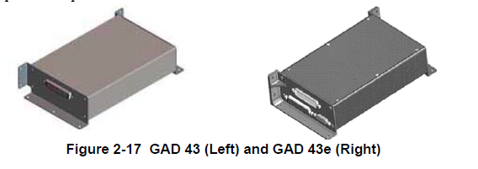

Figure 17 GAD 43 (Left) and GAD 43e (Right)

**EIS Components**

**Engine Annunciator**

An engine annunciator will only be installed if the EIS display is not installed within 8 inches of the center of the pilot’s field-of-view.

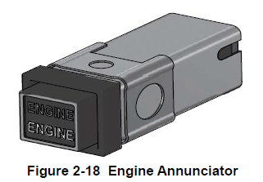

Figure 18 Engine Annunciator

**Carburetor Temperature Probe**

The carburetor temperature probe is a Type-K thermocouple (Chromel and Alumel) probe.

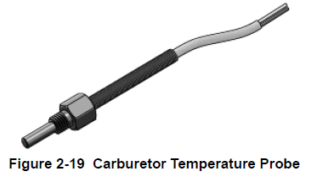

Figure 19 Carburetor Temperature Probe

**Oil Temperature Probe**

The oil temperature probe is a Type-K thermocouple (Chromel and Alumel) probe.

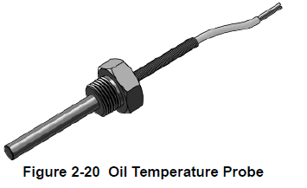

Figure 20 Oil Temperature Probe

**Fuel Flow Sensors**

The fuel flow sensor is incorporated in an aluminum housing that is installed in-line to the engine fuel supply. There are two STC approved options available for installation to suit most aircraft applications.

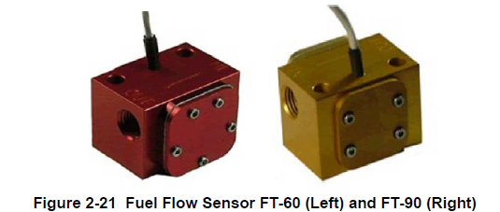

Figure 21 Fuel Flow Sensor FT-60 (Left) and FT-90 (Right)

**Brass Pressure Sensors**

The brass pressure sensors are small sensors that are supplied with a compatible plug. Depending on the installation, these sensors may be used to measure oil, fuel, and manifold pressure.

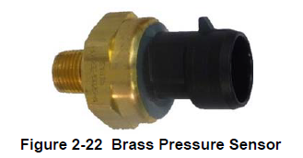

Figure 22 Brass Pressure Sensors

**Stainless Steel Pressure Sensors**

The stainless pressure sensors are unamplified, high-reliability sensors for harsh installation environments. There are four sensors available to measure oil, fuel, and manifold pressure.

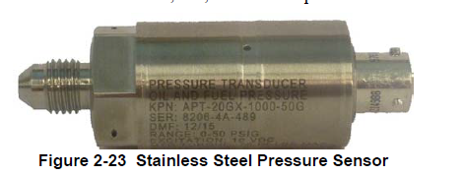

Figure 23 Stainless Steel Pressure Sensors

**P-Lead RPM Pickup**

A wire with two parallel resistors in-line connects from each P-lead, at the Magneto or the ignition switch, to the GEA 110 to sense RPM.

* 1. Physical Dimensions of G500 TXI

Physical Dimensions of G500 TXI can be seen at Figure 24.

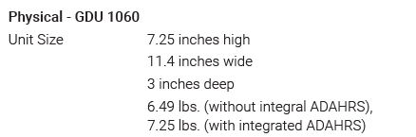

Figure 24 Physical Dimensions of G500 TXI (10”)

1. Garmin GMA 345 instead GMA 340

Since the GMA 340 is discontinued this year and, GMA 345 is introduced instead of GMS 340, we decided to change the previously decided avionic while still can. Garmin GMA 345 and 340 can be seen at Figures 25 and 26 respectively.

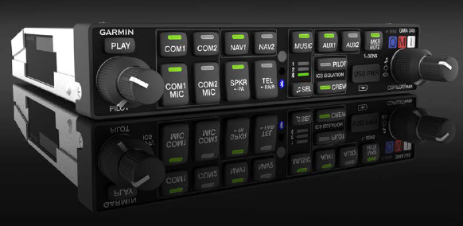

Figure 25 Garmin GMA 345

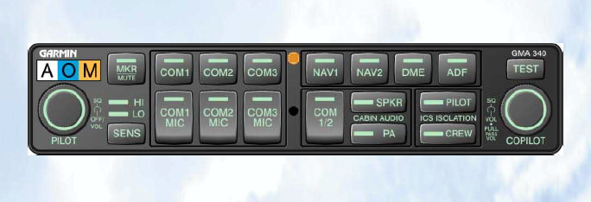

Figure 26 Garmin GMA 340

1. Garmin GTX 345 instead GMA 335

In its simplest terms, GTX 335 and 345 are same devices with one distinct difference. While both of these devices have ADB-S out capabilities which is compulsory for all planes, GTX 345 has ADB-s in capabilities that enables the plane to see its surroundings while collecting other planes ADB-S out data. Garmin GTX 345/335 can be seen at Figure 27.

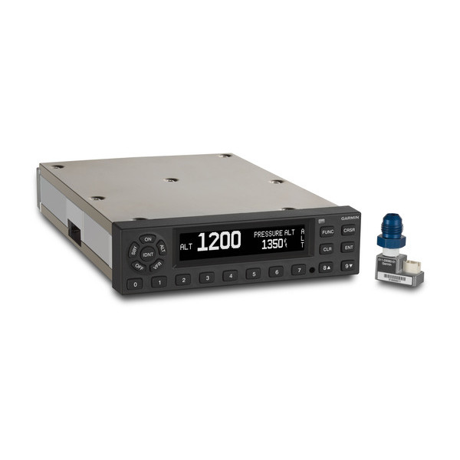

Figure 27 Garmin GTX 335/345

1. Some Usage Scenarios

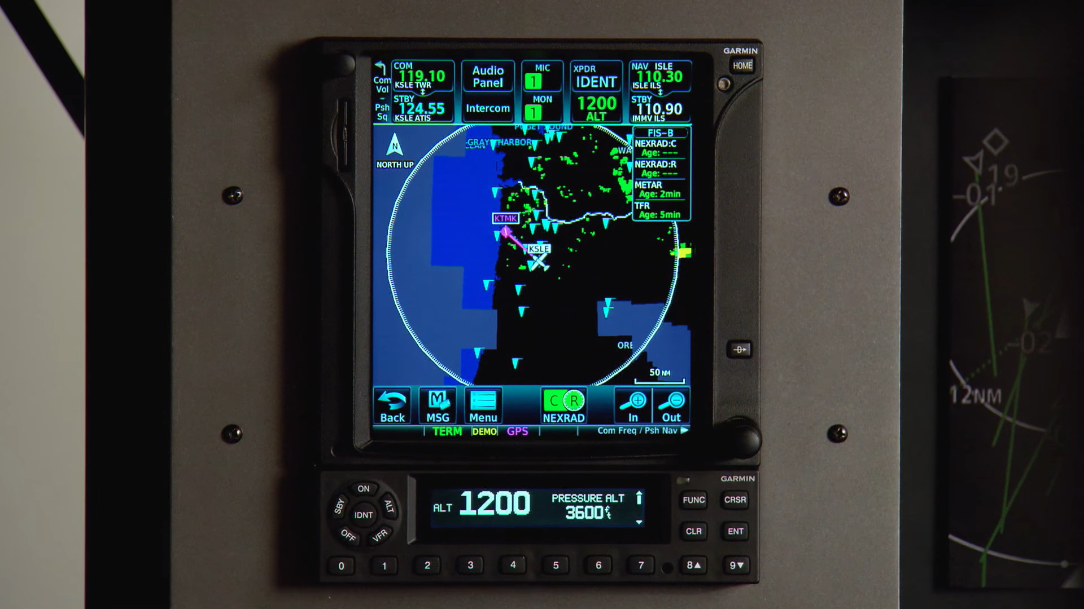

Figure 28 GTX 345 (Bottom) coupled with GTN 750 (Top)

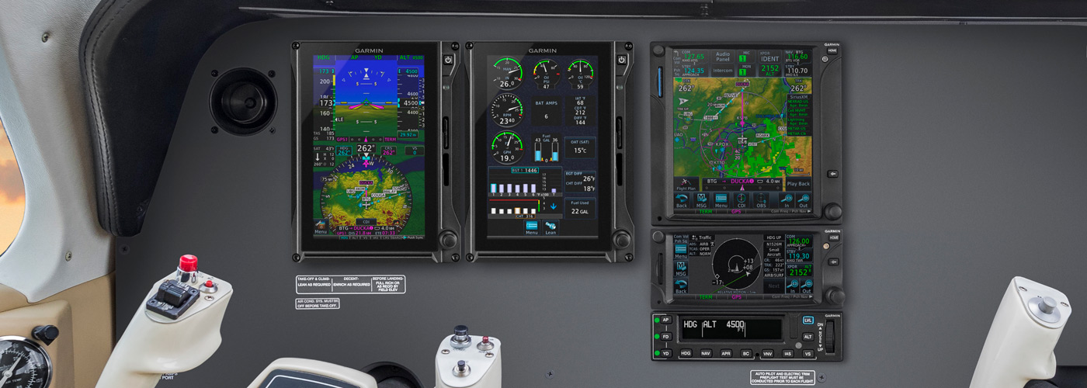

Figure 29 G500 TXI (Left) Coupled with GTN 750 (Top-Right)